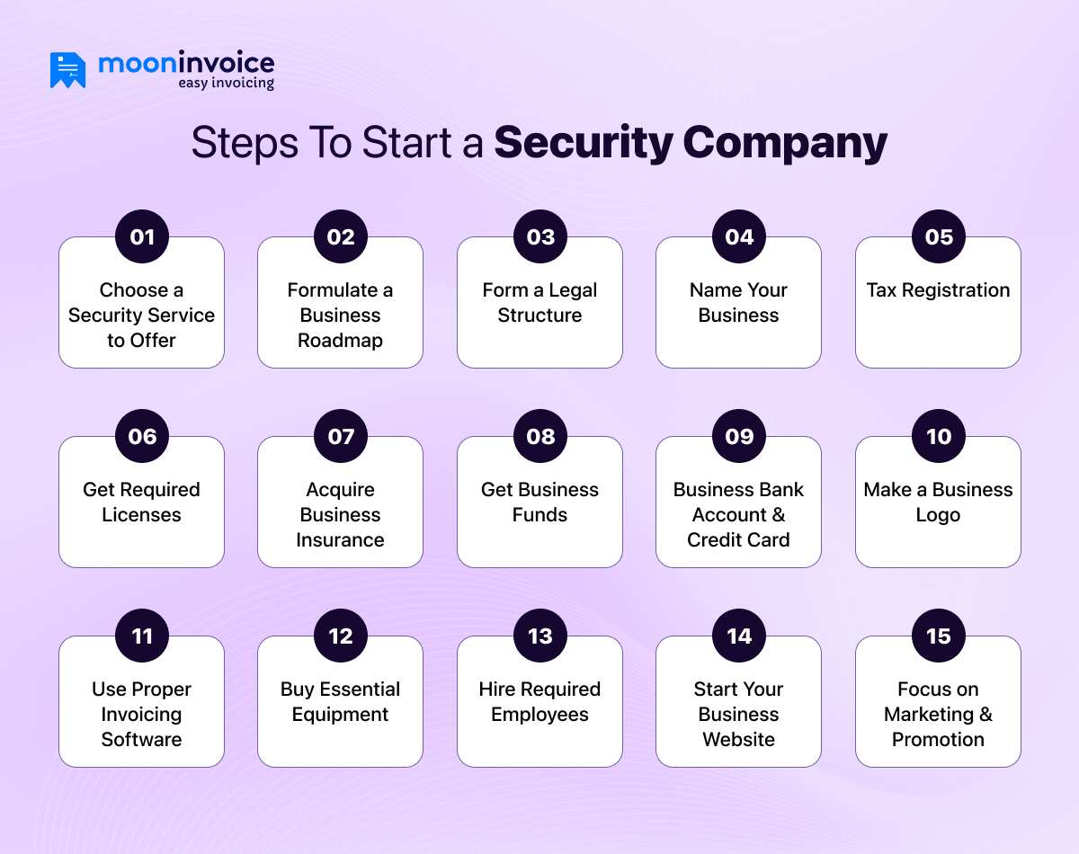
How to Start a Security Company? Tips & Cost You Should Know
Jayanti Katariya 14 Min Read Last Updated: December 5, 2025
How to Start a Security Company? Tips & Cost You Should Know
Published On: March 19, 2024
It might be challenging to manage a security company. However, it becomes fruitful when dedication and a solid plan are put into practice. Here is a sequential guide on starting a security firm.

Whether it is a bank, a corporate company, or a school, security plays a vital role everywhere. For this reason, new business aspirants often opt for security companies. The business has demonstrated remarkable growth and established a strong market presence.

According to the IBIS World report, the market size of the security services industry in California is $8.7 billion.

However, starting and managing a security company can also be a strenuous endeavor. The core operation includes planning, investment, legal procedures, and efforts. Additionally, there are many things in the operation.

The reality is that many young people have no idea how to start a security company. This is a big barrier to their business dreams. Yet, this blog will help to eliminate this problem. We’ll outline the crucial steps to follow for a successful security business, along with the capital investment required.

Key Takeaways
The security profession is a demanding job.
Professionals need to follow a solid business planning process to establish a security business.
Licenses, certificates, and legal permission are required to run this business.
Business aspirants do not have to invest a great deal to start a security company.
Technologies like real-time tracking and AI-powered tools are enhancing security services.
Table of Contents
How to Start a Security Company? Let’s Begin the Journey
How Much Does it Cost to Start a Security Company?
Why Opening a Security Company Is a Good Business Idea?
Verdict
FAQs

How to Start a Security Company? Let’s Begin the Journey
How to Start a Security Company Let’s Begin the Journey

Like any other startup company, a security service business requires robust business planning, investment, and a legal structure. Consider these key points before starting a security company.

- Choose a Security Service to Offer
Always decide on the type of security service you will deliver to your business. This will help ensure that funds and resources are available to you. A bad ending could result if you do not have a clear vision of the type of service you provide.

The types of professional security services are as follows.

Cybersecurity for internet technology security
Monitoring services and home security
Stationary guard services
Crisis management
Public space surveillance (CCTV)
- Formulate a Business Roadmap
You must create a business plan that includes all crucial steps of your business. Every startup is incomplete without a business plan. It is a significant tool for managing risk and following proper decision-making.

It contains a detailed description of how your business will achieve success from start to end. This will help to create a fine outlook for your business objectives.

Consider the following points before you open a security company.

Company Overview
Customer analysis
Competitor analysis
Marketing plan with 4Ps – Product, Price, Promotion, and Place
Operations plan
Management Team Information
Financial plan with an income statement, cash flow statement, and balance sheet
- Form a Legal Structure
When considering how to start a security guard company, don’t forget to include the legal process in your steps. You must register your company details with a reputable authority. If you fail to do so, you will be unable to accomplish crucial tasks like opening a bank account, taking out a loan, and hiring staff.

You must choose the legal entity type with which you need to register. During the legal process, you must prepare all necessary documents. It is essential to establish your business with a name, obtain tax registration, and develop a comprehensive business plan. You can opt for a corporation, LLC, or a DBA.

- Name Your Business
This is another prime strategy in the journey of starting a security company. Think & finalize the business name of your security company. You can use any name, but using a personal name may be recognized as unprofessional. Instead, you can use words like ‘national’ or ‘international’ to convey professionalism. It is recommended to use actual government regions because it is against the law.

Your business name should be capable of representing your brand. Also, it should be easy to pronounce and remember for the clients.

The business name should be unique and distinct from your competitors. Words like services, solutions, and consultants are worth noting.

Some examples of security company names are listed below.

Secure America Solutions
Liberty Security Solutions
- Tax Registration
Apply for tax registration before you open a security company. You must register for various state and federal taxes before you open a security guard company. Here, it is mandatory to obtain an Employer Identification Number (EIN). It helps the revenue department to track your company easily. Hence, an accurate tax process is in place.

You must contact your accountant or attorney in case you are unsure which state or federal taxes you are liable for.

- Get Required Licenses
Obtaining a license is crucial when considering how to start a security company. The licenses you need can vary according to your location. You must maintain a basic understanding of the security industry. You should demonstrate that you possess the necessary talent and skills to deliver the best security services. For the business, the following licenses are needed.

  - Private Patrol Operator License
There is a need for proof to justify your skills for a security guard company. Additionally, you should have at least four years of experience as a security guard. The license cost will range from $500 to $1,200 or more, depending on the location. The fees are bifurcated as an initial application fee and an initial license fee.

  - Security Guard License
Security guard licenses serve as proof of a person’s ability to perform the duties and responsibilities of a security guard. For instance, if candidates receive training to enhance their skills from the California Bureau of Security, the corresponding fee will be applicable.

  - Qualified Manager License
This is another important license for starting a security company. It is essential to note that a qualified person with security manager experience operates your company. The manager should possess at least two years of consecutive experience. The application fee of $25 is applicable to apply for this license.

- Acquire Business Insurance
Opting for insurance is another crucial aspect of the security guard business. There are two types of insurance for a security guard company.

Liability insurance protects you when your client falls into a mishap.
Bonding insurance when your employee steals your client’s property.
When deciding on an insurance type, it’s essential to know your niche. It is also beneficial to compare your insurance plans and consult an insurance broker.

- Get Business Funds
Of course, your business will require some investment and expenses to operate. Opting for a bank loan is one of the best options if you don’t want to disturb your savings. You can choose SBA loans that provide lower interest rates.

Ensure you have all the necessary documents ready before applying for the loan. The bank will need all the business-related documents related to legal work and your income statements. Additionally, they will also check your credit history.

- Business Bank Account & Credit Card
Open a business bank account for your security company to ensure its financial security. It helps smooth business transactions and keeps your capital safe. Furthermore, it enhances security measures, such as multi-factor authentication and encryption.

Also, professionals need to apply for a credit card. This will enhance easy payment and cash flow. It is also applicable to accessing capital and resources easily.

However, you must have all the necessary documents clear and ready to open a bank account and a credit card.

Documents required for bank account opening

Employer Identification Number (EIN)
Documents of business formation
Business License
Ownership agreement
Documents to apply for a credit card

Name of the business
Address and contact information
Annual business revenue
Business introduction or description
Employer Identification Number (EIN)
Estimate of monthly spending
- Make a Business Logo
A business logo is as valuable as a business name. It is because it helps in branding your business. The private security business logo should be closely aligned with your business niche. The logo should be memorable, which makes it easy for people to recognize your brand.

Along with relevancy, the logo should be simple and sober. It should be designed in a way that makes it look professional and catchy while advertising. For this, you can do competitor research and use logo design software.

- Use Proper Invoicing Software
Use Proper Invoicing Software

A proper invoicing process is essential for maintaining accurate business billing. It builds trust among your customers. Therefore, it is essential to select the right invoicing software when establishing a security company.

However, the traditional method of creating an invoice may not be the best option. Proper invoicing software is a boon to ensuring a proper invoicing process.

Moon Invoice is the ideal platform, offering a wide range of invoice templates. It streamlines the invoicing process for the security business with pre-designed templates. With the top invoicing software, it is easy to generate bulk invoices with the correct data and calculations

